**TABLEAU HOMEWORK – CITIBIKE ANALYSIS**

**CHINEDU NWAKA, 10.27.2019**

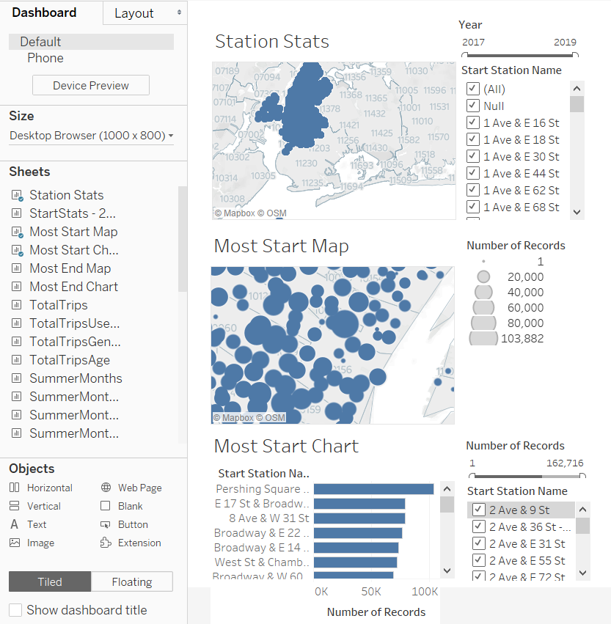

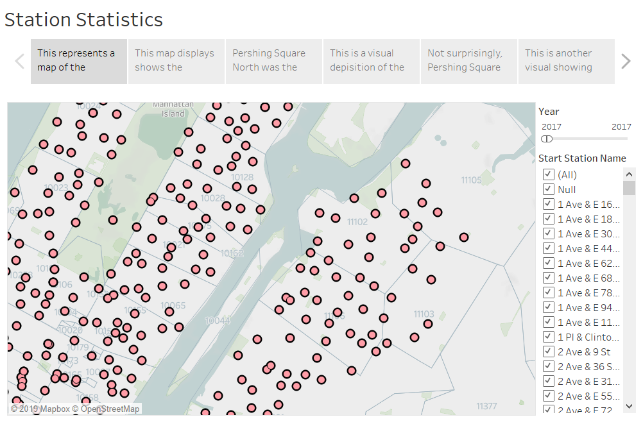

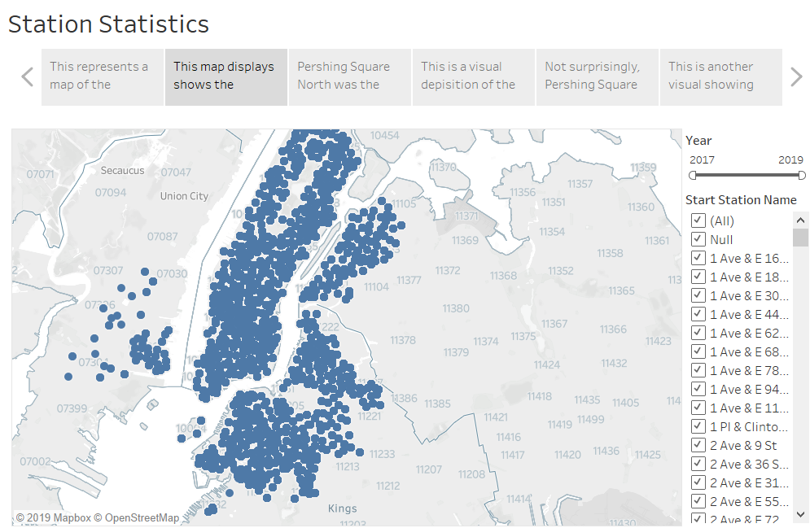

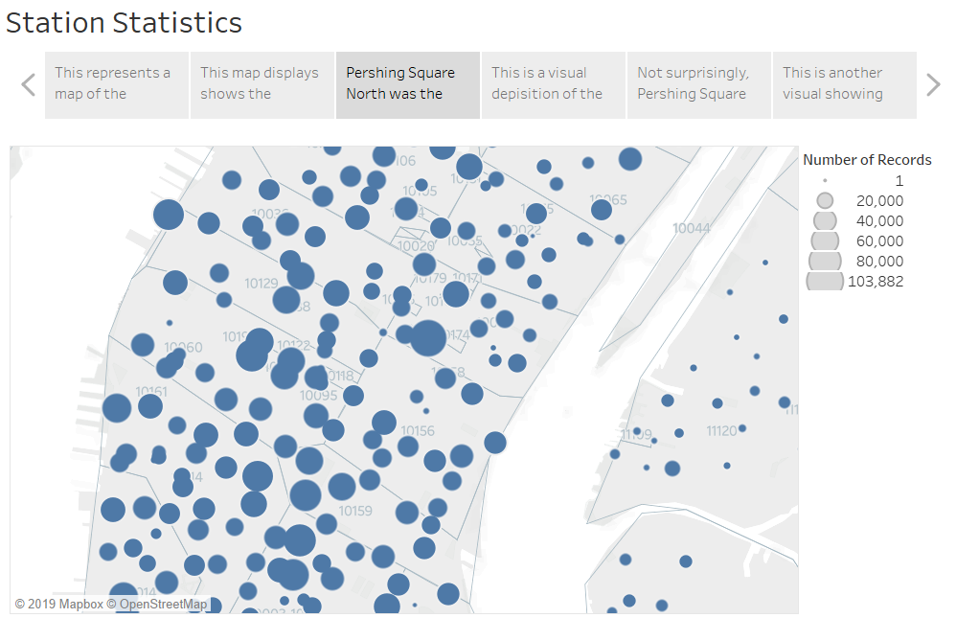

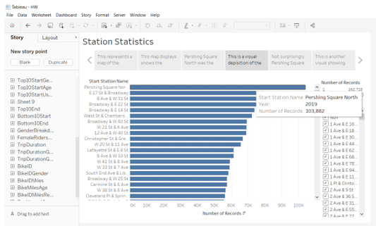

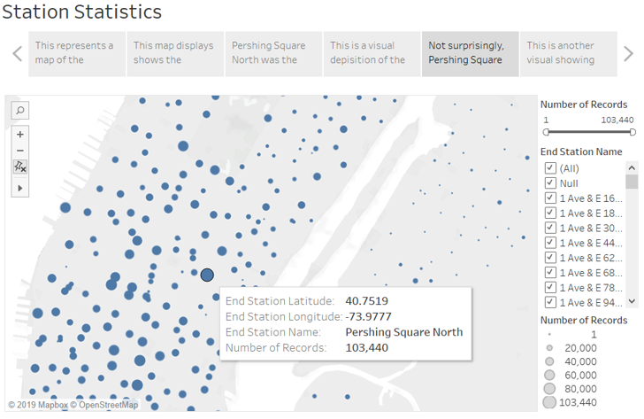

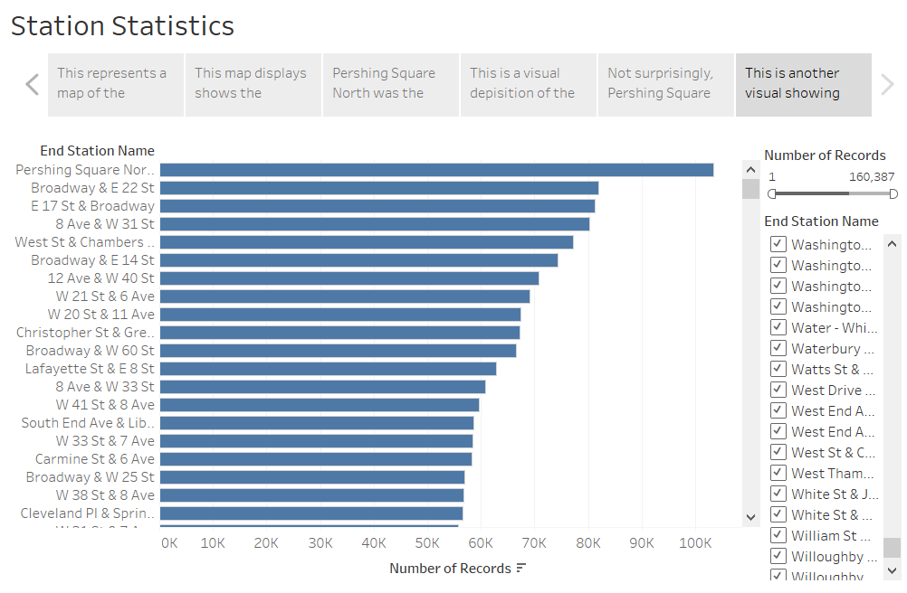

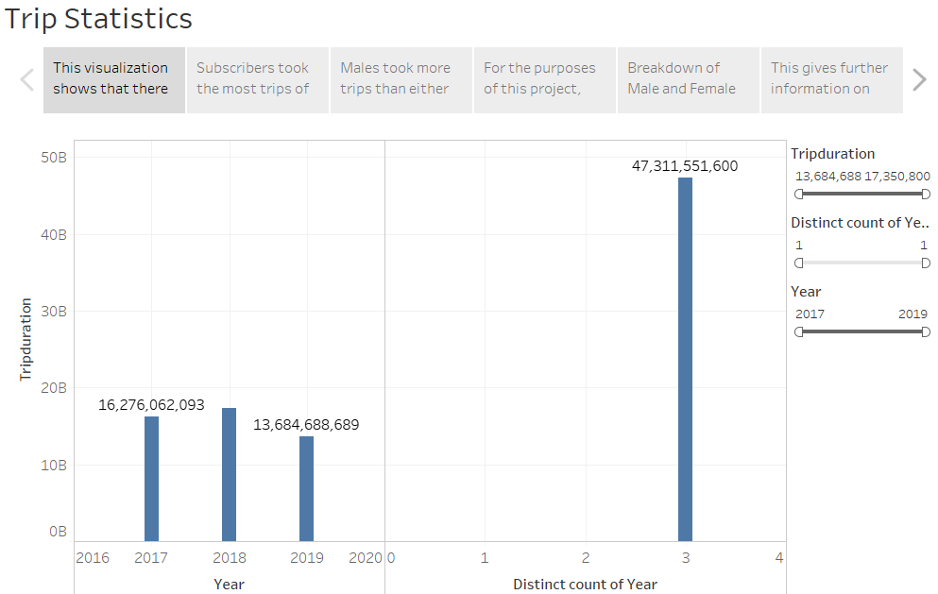

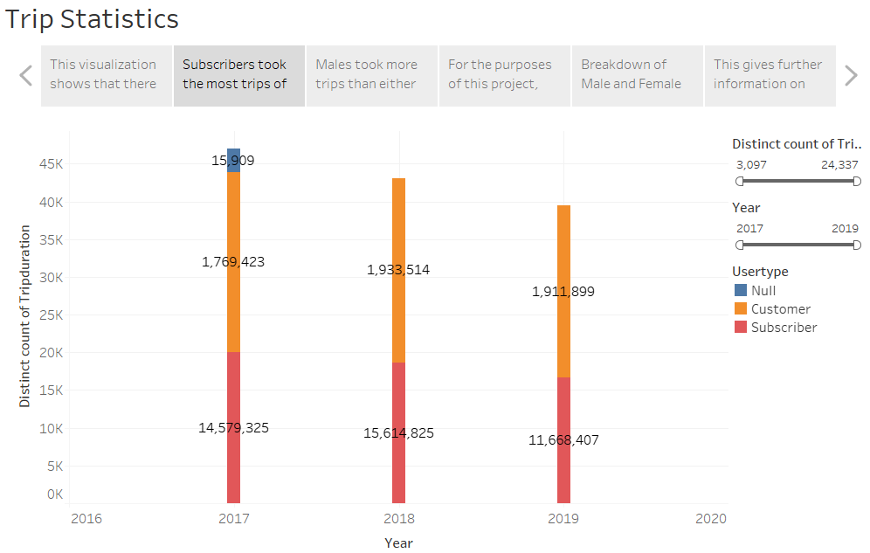

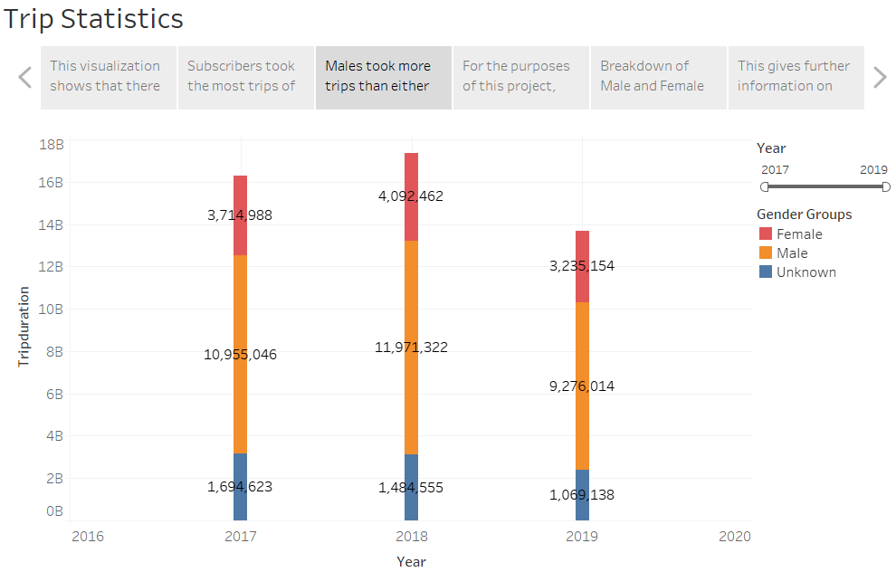

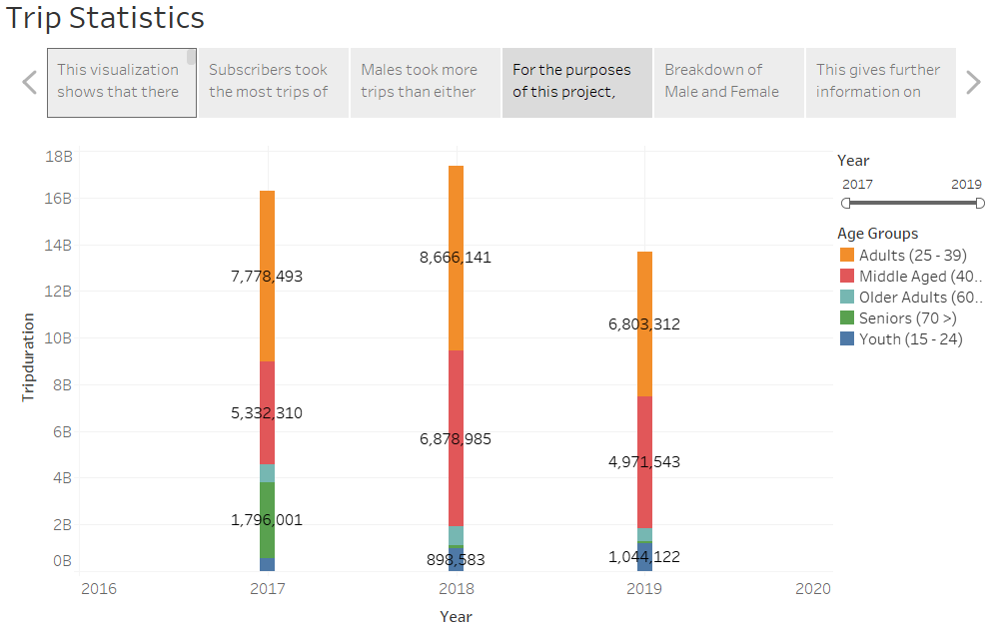

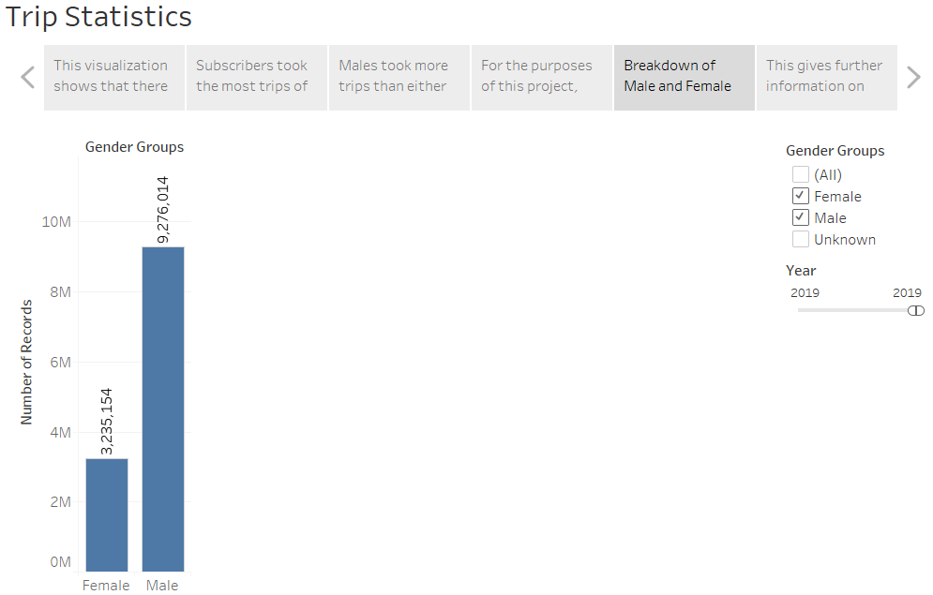

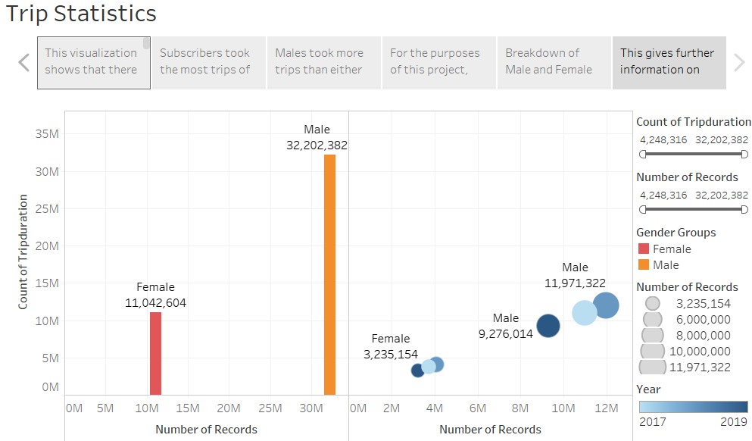

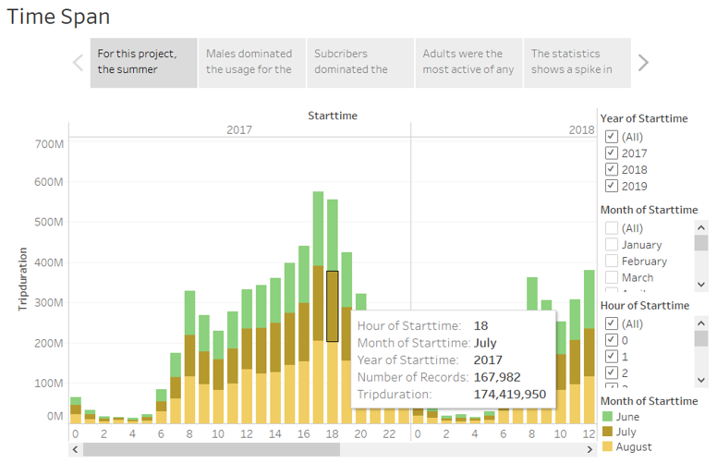

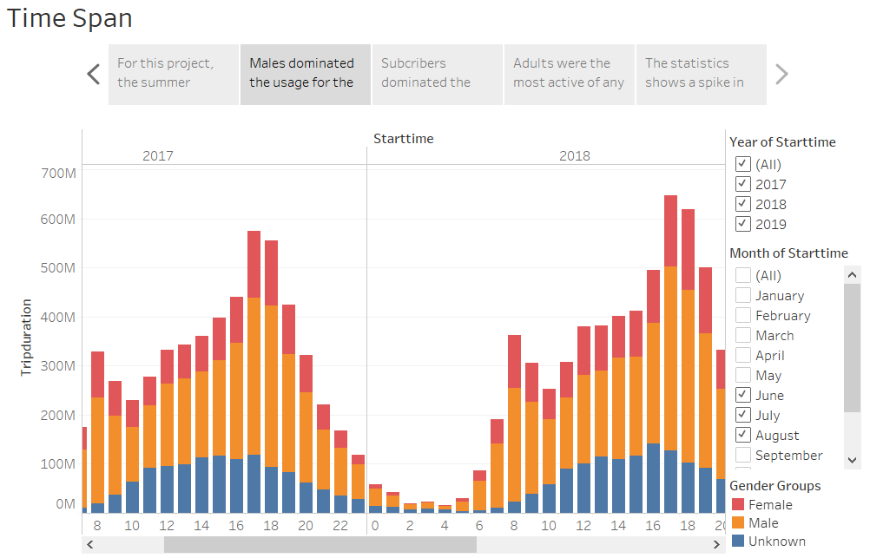

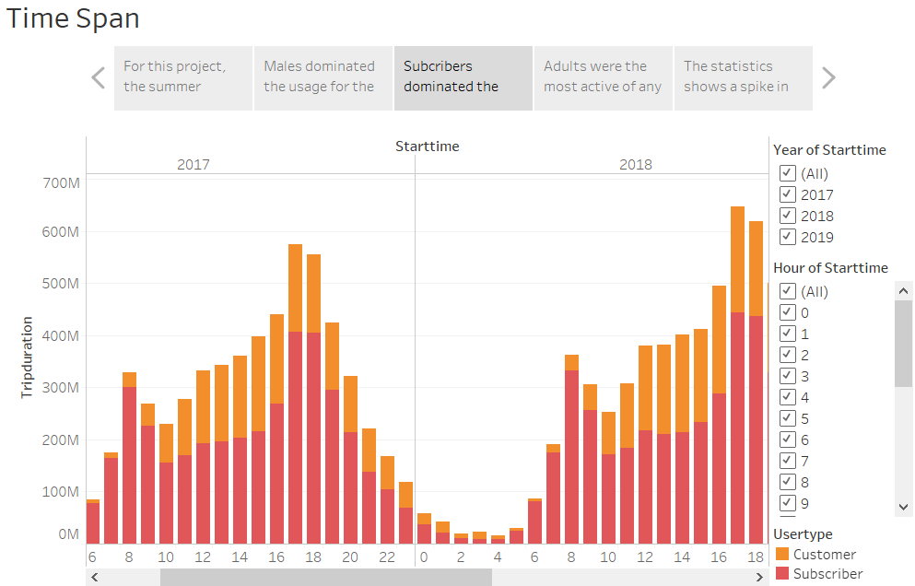

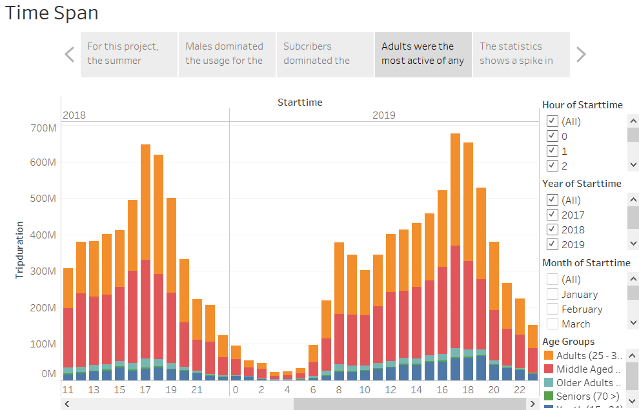

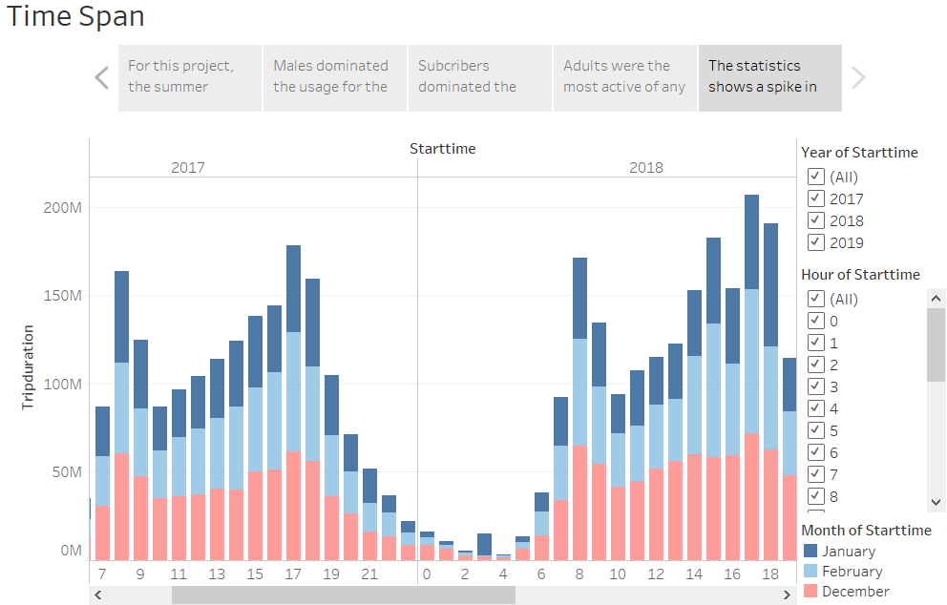

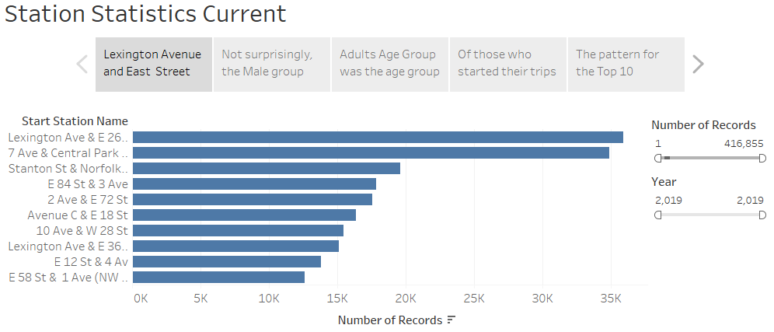

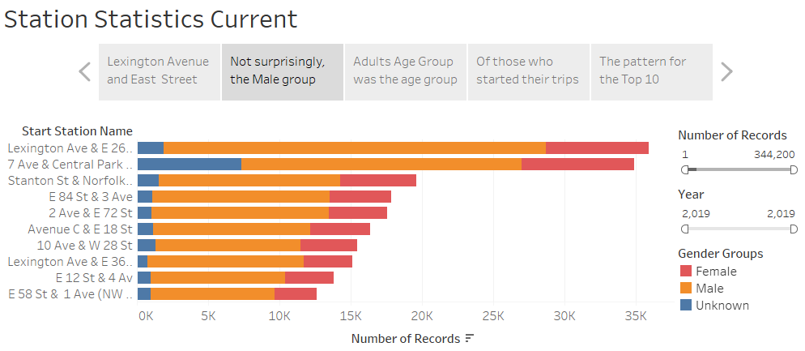

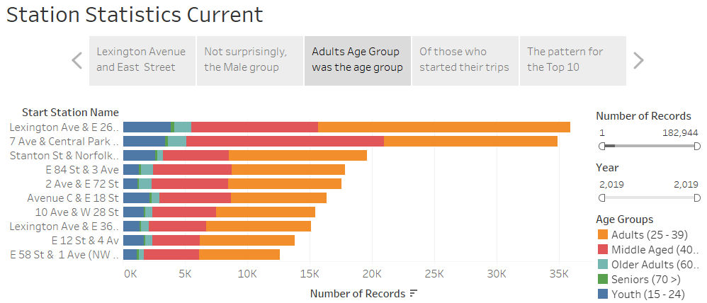

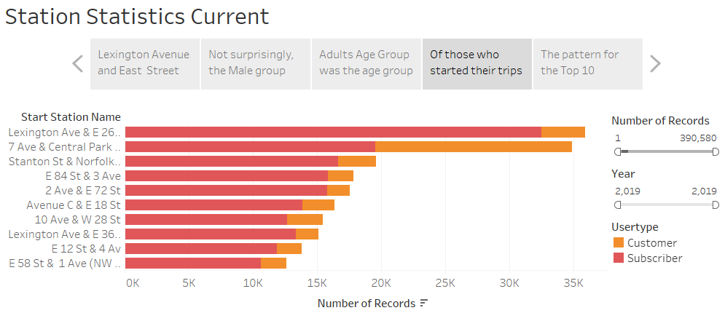

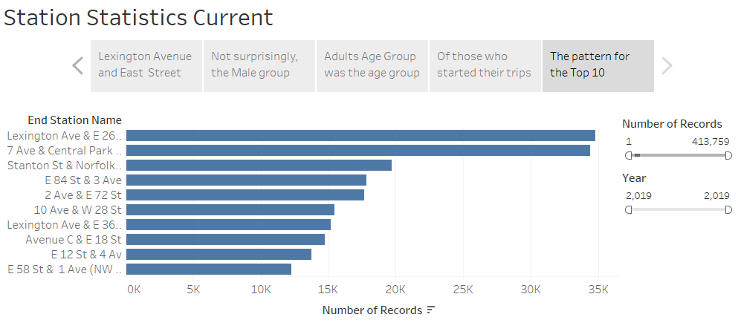

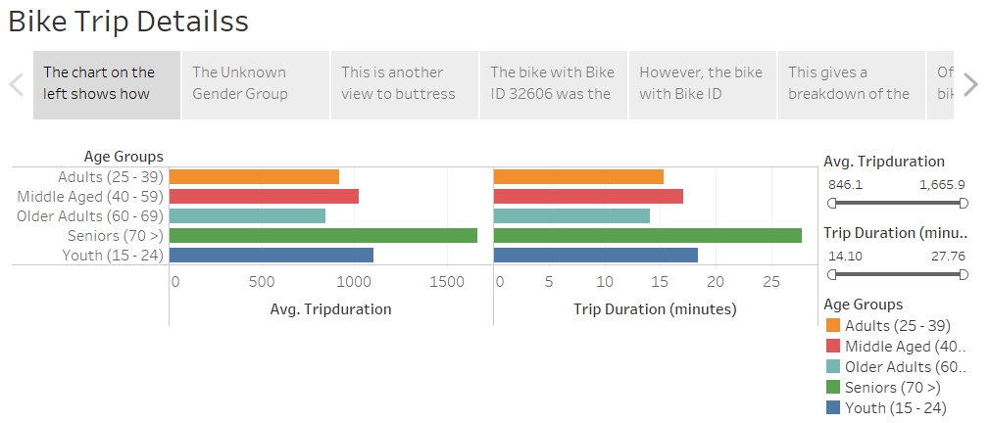

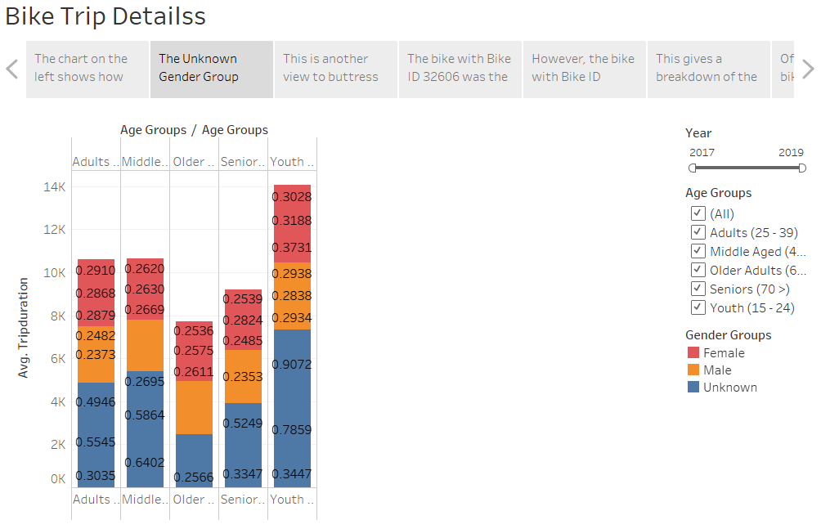

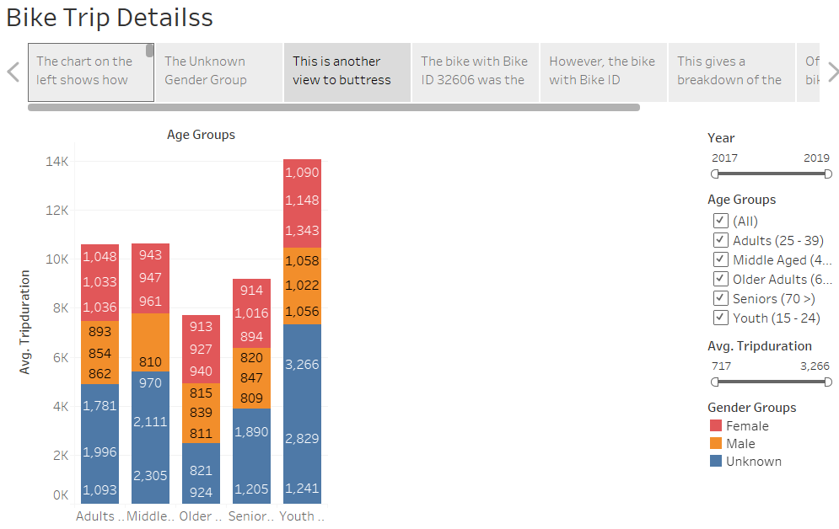

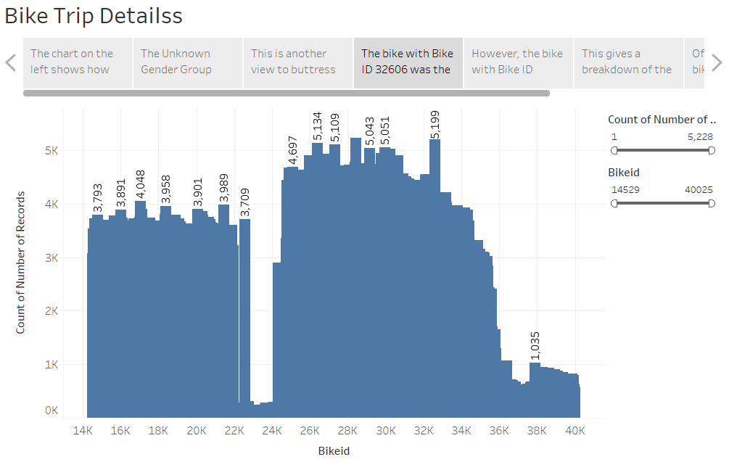

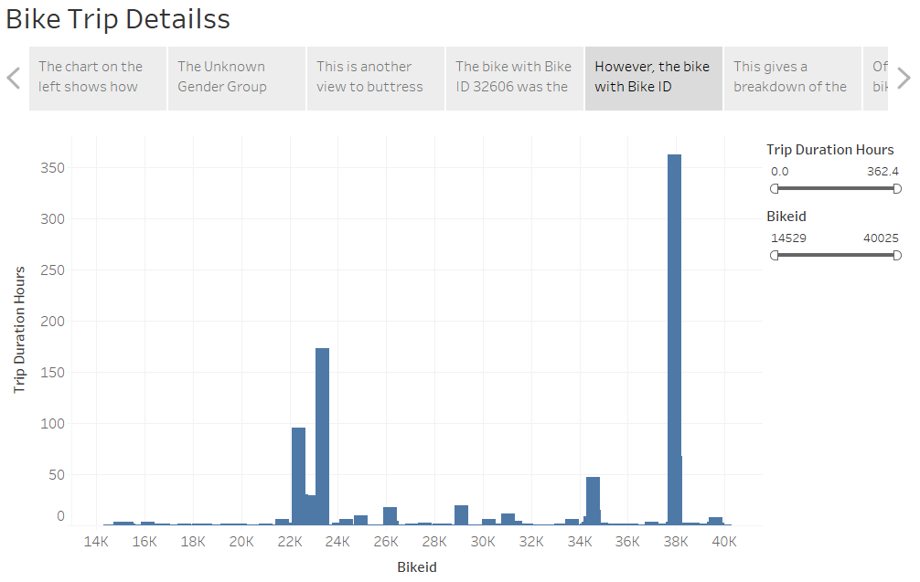

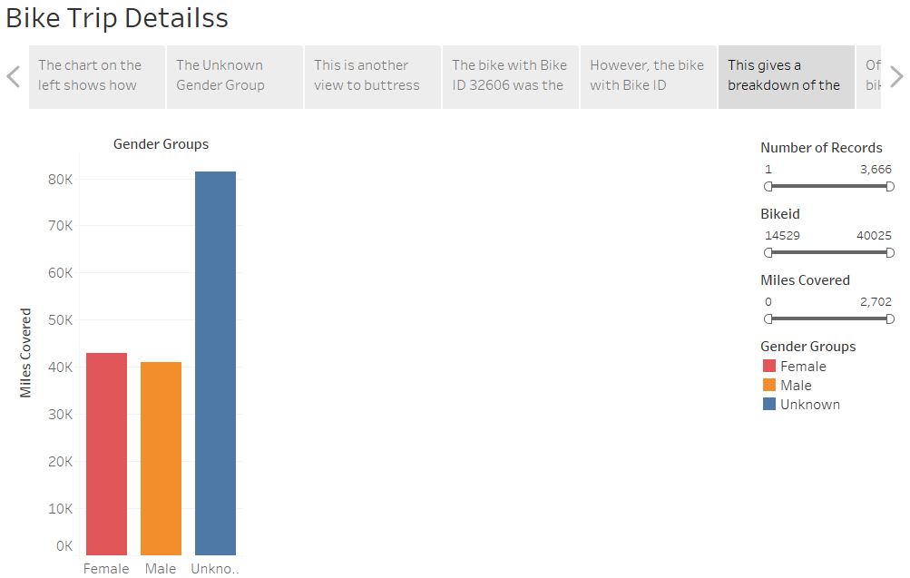

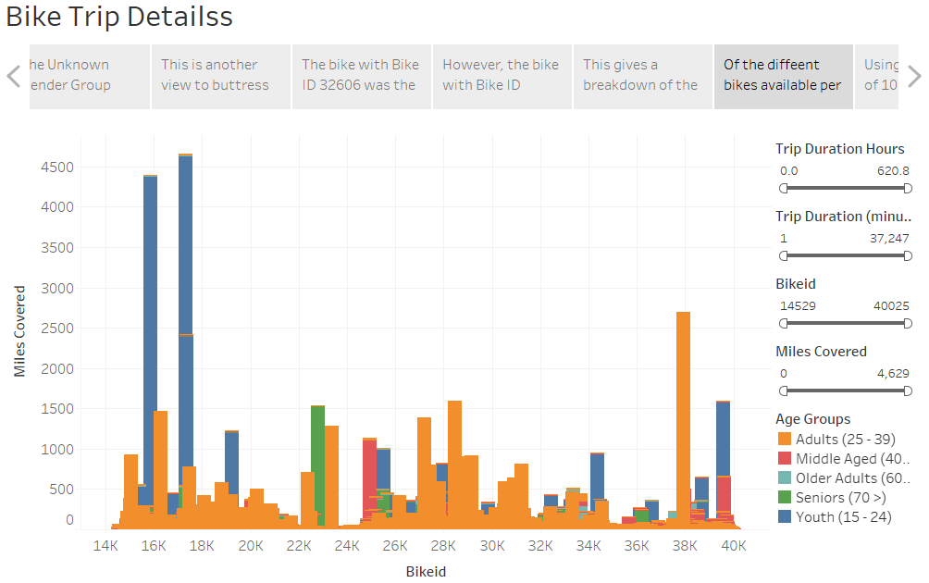

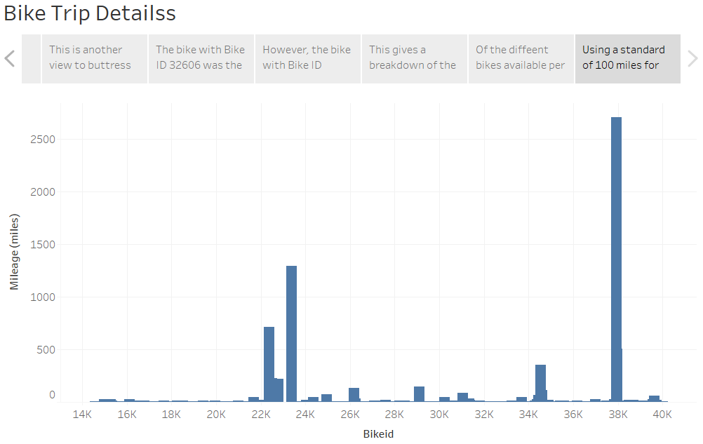

**SUMMARY:**

The data analyzed was from January 2017 to August 2019, as a result, the analysis for the winter months of 2019 was missing data for the month of December, and also, it was not possible to show the exact increases in different parameters over the years for the same reason.

**Station Statistics:** There was some increase in the number of stations over the period. Pershing Square North station was simultaneously the top station in terms of starting and ending journeys overall.

**Trip Statistics:** Even though the last year in the series 2019 was yet to end, it was clear there was a trend in the increase in ridership, and the available data did not indicate this trend was not going to continue. For the 3 years under review, “Adult”, “Male” “Subscribers” made up a disproportionately larger number of the total users. Users were put into 5 age groups; Youth (15 – 24), Adults (25 – 39), Middle Age (40 – 59), Older Adults (60 – 69), Seniors (70 >); 3 gender groups (Male, Female and Unknown); 2 user types (Customers and Subscribers). Both male and female ridership increased over the period.

**Time Span:** During the summer month for each year analyzed, adult male subscribers were the most active riders, and the peak hours for all the years were between 5pm and 6pm. However, the winter months generally noticed two spikes in peaks usage; at 8am in the mornings and again between 5pm and 6pm.

**Station Statistics – Current:** Just like earlier, there was pattern here with the choice of stations for both starting and ending journeys – Lexington Avenue and East 26 Street was the top station, and the top 10 stations for starting were the top 10 stations for ending trips, but not in the same exact order. Again, male adult subscribers were the top users for the stations

**Bike Trip Details:** Surprisingly, the available data suggests that Seniors of the Unknown gender group spent the most time riding the bikes on the average, although, this may be due to wrong date of births being recorded, especially in 2017. However, the Youth group rode the bikes farthest, as they covered the mot distances ridden. The bike with Bike ID 32606 was the bike most ridden, however, the bike with ID 37947 was the bike ridden the farthest covering 2,702 miles for the period under review. Applying a standard of repairs after 1,000 miles and inspection after 500 miles, the bikes with Bike IDS 23368 and 37947 require repairs while the bike with ID 22357 needs to be inspected.

In conclusion, marketing efforts to attract females seems to be achieving some success, as the number of female riders continues to grow, but not at the same rate as males or unknowns, so further strategies to attract female riders may be beneficial. The fact that Seniors take the longest time to ride the bikes on the average, creates some cross-selling and marketing opportunities that targets them. Also, it may be worth the trouble to provide enhanced safety devices on the bikes because of the Seniors. The subscriber base is impressive, and more efforts can be geared towards converting customers to subscribers to create increased revenue from annual subscription fees. The most active users are adult males, so extra work to attract and retain the youth may be beneficial, because, they are surprisingly not the most active users. Advertisement slots targeting adult male subscriber users may be beneficial, especially within the top 10 stations, and incentive deals could be struck with different brands and corporate bodies, as a sort of rewards package for this category of users.